Lab 1: Understanding ORM with a Retail Inventory System
Scenario
A retail store wants to build an inventory management system to track products, categories, and stock levels using a SQL Server database. Entity Framework Core (EF Core) is used as the Object Relational Mapper (ORM) to connect C# classes with relational database tables.
Objective
- Understand the concept of ORM (Object Relational Mapping).
- Learn how Entity Framework Core maps C# classes to SQL Server tables.
- Create a .NET Console Application.
- Configure SQL Server using EF Core.
- Perform database migration and create the database.
What is ORM?
ORM (Object Relational Mapping) is a technique that maps C# classes (objects) to relational database tables.
Instead of writing SQL queries manually, developers work with C# objects. EF Core automatically converts C# operations into SQL queries.
Example
C# Class
public class Product
{
public int ProductId { get; set; }
public string Name { get; set; }
public decimal Price { get; set; }
public int Stock { get; set; }
}
Database Table
ProductId | Name | Price | Stock
1 | Laptop | 55000 | 10

Benefits of ORM
- Reduces SQL coding.
- Increases developer productivity.
- Easy maintenance.
- Automatic mapping between objects and tables.
- Database-independent programming.
- Supports LINQ queries.
- Improves code readability.
EF Core vs Entity Framework (EF6)
EF Core | Entity Framework (EF6)
Cross-platform | Windows only
Lightweight | Heavy
Better performance | Slower
Supports .NET 8 | Supports .NET Framework
Supports LINQ | Supports LINQ
Async queries | Async queries
Modern architecture | Older architecture
EF Core 8.0 Features
- JSON column mapping
- Compiled models for better performance
- Interceptors
- Improved bulk operations
- Better query performance
- Faster startup time
- Better LINQ translation
Create the Console Application
Created a Console Application in Visual Studio.
Equivalent command:
dotnet new console -n RetailInventory
Move into the project folder:
cd RetailInventory
Install EF Core Packages
Installed the following packages:
Install-Package Microsoft.EntityFrameworkCore.SqlServer -Version 8.0.8
Install-Package Microsoft.EntityFrameworkCore.Design -Version 8.0.8
Install-Package Microsoft.EntityFrameworkCore.Tools -Version 8.0.8
Create Model Classes
Created Product.cs
namespace RetailInventory.Models
{
public class Product
{
public int ProductId { get; set; }
public string Name { get; set; } = string.Empty;
public decimal Price { get; set; }
public int Stock { get; set; }
}
}
Created Category.cs
using System;
using System.Collections.Generic;
using System.Linq;
using System.Text;
using System.Threading.Tasks;
namespace RetailInventory.Models
{
public class Category
{
public int CategoryId { get; set; }

public string CategoryName { get; set; }
}
}

Create DbContext
Created InventoryContext.cs
Configured SQL Server LocalDB.
using Microsoft.EntityFrameworkCore;
using RetailInventory.Models;

namespace RetailInventory.Data
{
public class InventoryContext : DbContext
{
public DbSet<Product> Products { get; set; }
public DbSet<Category> Categories { get; set; }

protected override void OnConfiguring(DbContextOptionsBuilder optionsBuilder)
{
optionsBuilder.UseSqlServer(
@"Server=(localdb)\MSSQLLocalDB;Database=RetailInventoryDB;Trusted_Connection=True;TrustServerCertificate=True");
}

protected override void OnModelCreating(ModelBuilder modelBuilder)
{
modelBuilder.Entity<Product>()
.Property(p => p.Price)
.HasPrecision(10, 2);
}
}
}
Create Migration
Executed:
Add-Migration InitialCreate
Migration created successfully.
Create Database
Executed:
Update-Database
Database created successfully.
Database Name:
RetailInventoryDB
Insert Sample Data
Created Program.cs
using RetailInventory.Data;
using RetailInventory.Models;

namespace RetailInventory
{
internal class Program
{
static void Main(string[] args)
{
using (var db = new InventoryContext())
{
var product = new Product
{
Name = "Laptop",
Price = 55000m,
Stock = 10
};

db.Products.Add(product);
db.SaveChanges();
}

Console.WriteLine("Product inserted successfully!");
Console.ReadLine();2
}
}
}
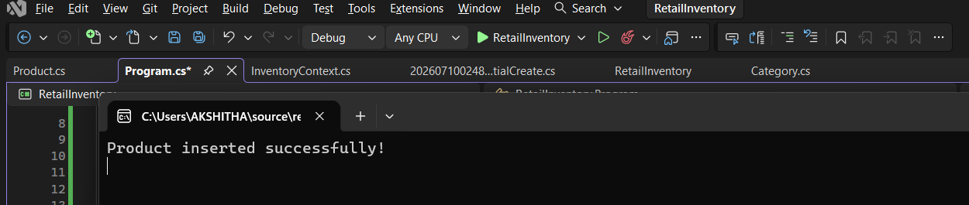
Output:

Verify Database
Opened SQL Server Management Studio.
Connected to:
(localdb)\MSSQLLocalDB
Opened
RetailInventoryDB
Expanded
Tables
Viewed
dbo.Products
Verified inserted records.
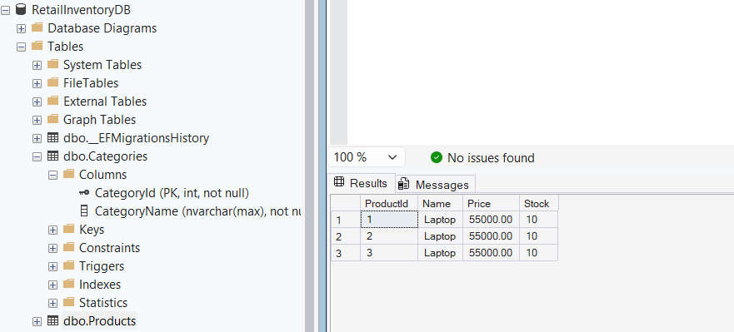
Output:

Lab 2: Setting Up the Database Context for a Retail Store
Scenario
A retail store wants to store product and category information in a SQL Server database. Entity Framework Core (EF Core) is used to configure the database context and establish a connection between C# classes and SQL Server.
Objective
- Configure DbContext using Entity Framework Core.
- Connect a .NET Console Application to SQL Server.
- Create model classes for Product and Category.
- Configure SQL Server LocalDB using EF Core.
- Perform database migration.
- Create the SQL Server database successfully.
Create the Console Application
Created a Console Application in Visual Studio.
Equivalent command:
dotnet new console -n RetailStoreEF
Move into the project folder:
cd RetailStoreEF
Install EF Core Packages
Installed the following NuGet packages:
Install-Package Microsoft.EntityFrameworkCore
Install-Package Microsoft.EntityFrameworkCore.SqlServer
Install-Package Microsoft.EntityFrameworkCore.Tools
Installation completed successfully.
Create Model Classes
Created Category.cs
using System.Collections.Generic;
namespace RetailStoreEF.Models
{
public class Category
{
public int Id { get; set; }

public string Name { get; set; }

public List<Product> Products { get; set; }
}
}
Created Product.cs
namespace RetailStoreEF.Models
{
public class Product
{
public int Id { get; set; }

public string Name { get; set; }

public decimal Price { get; set; }

public int CategoryId { get; set; }

public Category Category { get; set; }
}
}
Create DbContext
Created AppDbContext.cs
Configured SQL Server LocalDB.
using Microsoft.EntityFrameworkCore;
using RetailStoreEF.Models;

namespace RetailStoreEF.Data
{
public class AppDbContext : DbContext
{
public DbSet<Product> Products { get; set; }

public DbSet<Category> Categories { get; set; }

protected override void OnConfiguring(DbContextOptionsBuilder optionsBuilder)
{
optionsBuilder.UseSqlServer(
"Server=(localdb)\\MSSQLLocalDB;Database=RetailStoreDB;Trusted_Connection=True;TrustServerCertificate=True;");
}
}
}
Create Migration
Opened Package Manager Console and executed:
Add-Migration InitialCreate
Migration created successfully.
Create Database
Executed:
Update-Database
Verify Database
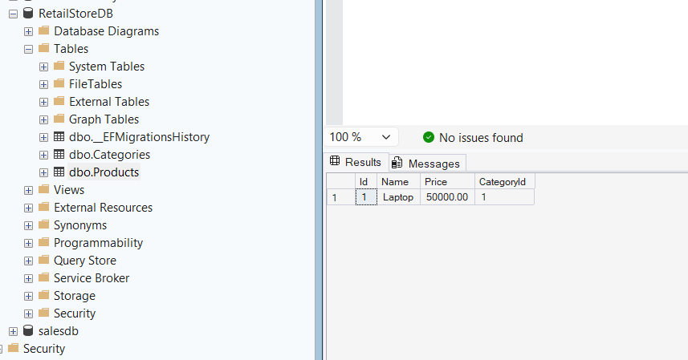
Output

Lab 3: Using EF Core CLI to Create and Apply Migrations
Scenario
The retail store's database needs to be created based on the models defined in the Retail Inventory project. Entity Framework Core (EF Core) CLI is used to generate migrations and create the SQL Server database.
Objective
To learn how to use Entity Framework Core CLI to manage database schema changes by creating and applying migrations.
Install EF Core CLI
Opened the Visual Studio Terminal and executed the following command to install the Entity Framework Core CLI tool.
Command:
dotnet tool install --global dotnet-ef
Output:
Create the Initial Migration
Executed the following command to generate the initial migration.
Command:
dotnet ef migrations add InitialCreate
Output:
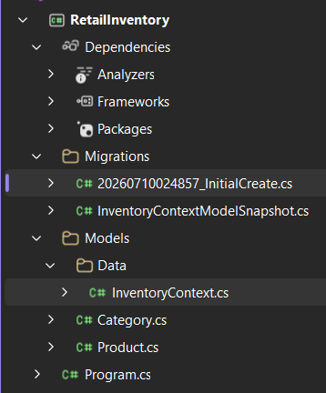
Apply Migration to Create the Database
Executed the following command to apply the migration and create/update the database.
Command:
dotnet ef database update
Output:
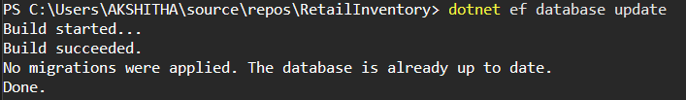
Verify the Database in SQL Server
Opened SQL Server Management Studio (SSMS) and connected to the SQL Server instance.
Verified that the database:
RetailInventoryDB
was created successfully.
Expanded the Tables folder and confirmed that the following tables were present:
- Products
- Categories
This confirms that the migration was successfully applied and the database schema was created correctly.

Output:
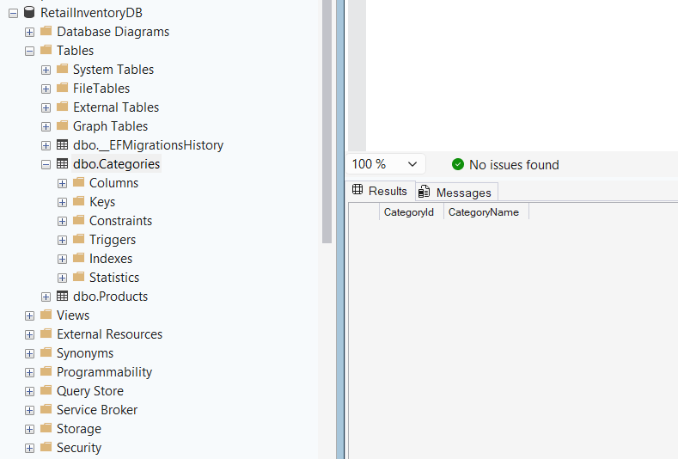

Lab 4: Inserting Initial Data into the Database
Scenario
The store manager wants to add initial product categories and products to the retail inventory system.
Objective
To use Entity Framework Core to insert records into the SQL Server database using AddRangeAsync() and SaveChangesAsync().
Opened the Project
- Opened the RetailInventory project in Visual Studio.
- Verified that the project was successfully built.
Updated the Entity Classes
Modified the Category model by:
- Initializing the CategoryName property with string.Empty.
- Adding a navigation property to establish a one-to-many relationship with the Product entity.
Modified the Product model by:
- Including properties such as ProductId, Name, Price, Stock, and CategoryId.
- Adding a navigation property to reference the associated category.
Updated the DbContext
Modified the InventoryContext class by:
- Configuring the SQL Server database connection.
- Defining DbSet<Product> and DbSet<Category>.
- Configuring the Price property precision.
- Configuring the one-to-many relationship between Category and Product using the Fluent API.
Inserted Sample Data
Created two category objects:
- Electronics
- Groceries
Added the categories to the database context using:
- AddRangeAsync()
Created two product objects:
- Laptop
- Rice Bag
Associated each product with its respective category.
Added the products to the database context using:
- AddRangeAsync()
Saved all the changes to the database using:
- SaveChangesAsync()
Handled Exceptions
Implemented a try-catch block to:
- Detect database errors.
- Display exception details if an error occurred during data insertion.
Built the Project
Built the project successfully in Visual Studio.
Generated Migration
Opened the Package Manager Console and executed:
Add-Migration InitialCreate
This generated the migration files required to create the database schema.
Updated the Database
Executed the following command:
Update-Database
This created the RetailInventoryDB database and generated the required tables.
Ran the Application
Executed the application using:
dotnet run
or by pressing:
Ctrl + F5
The application inserted the sample category and product records into the SQL Server database.
Verified the Database
Opened SQL Server Management Studio (SSMS) / SQL Server Object Explorer.
Verified that the following tables were created:
- Categories
- Products
Executed the following SQL queries:
select * from Categories;
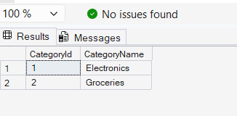
select * from Products;
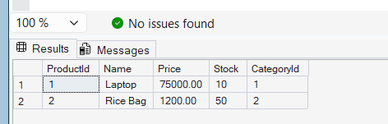
select
p.Name,
p.Price,
c.CategoryName
from Products p
join Categories c
on p.CategoryId = c.CategoryId;
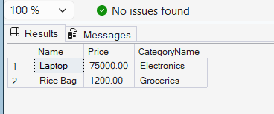
Output:

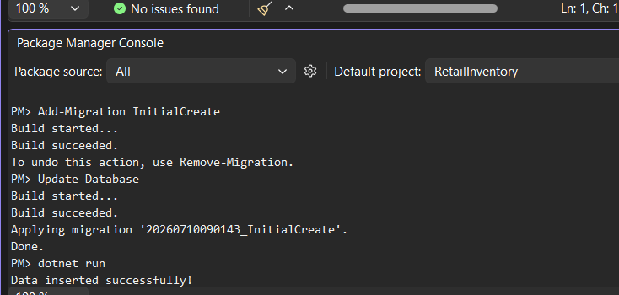
Lab 5: Retrieving Data from the Database
Scenario
The retail store wants to display product details on the dashboard by retrieving information stored in the SQL Server database.
Objective
To retrieve data from the database using Entity Framework Core asynchronous methods such as ToListAsync(), FindAsync(), and FirstOrDefaultAsync().
Steps Performed
Opened the Existing Project
- Opened the RetailInventory project in Visual Studio.
- Used the database that was created and populated during Lab 4.
Opened Program.cs
- Opened the Program.cs file.
- Removed the data insertion code from the previous lab.
- Added code to retrieve data from the database.

using Microsoft.EntityFrameworkCore;
using RetailInventory.Data;

using var context = new InventoryContext();

try
{
// Retrieve all products
Console.WriteLine("----- All Products -----");

var products = await context.Products.ToListAsync();

foreach (var p in products)
{
Console.WriteLine($"{p.Name} - ₹{p.Price}");
}

Console.WriteLine();

// Find product by ID
Console.WriteLine("----- Find Product by ID -----");

var product = await context.Products.FindAsync(1);

Console.WriteLine($"Found: {product?.Name}");

Console.WriteLine();

// Retrieve first product whose price is greater than 50000
Console.WriteLine("----- Expensive Product -----");

var expensive = await context.Products
.FirstOrDefaultAsync(p => p.Price > 50000);

Console.WriteLine($"Expensive: {expensive?.Name}");
}
catch (Exception ex)
{
Console.WriteLine(ex.Message);
}
Retrieved All Products
- Used the ToListAsync() method to retrieve all records from the Products table.
- Stored the retrieved records in a list.
- Displayed the product name and price for each product using a foreach loop.
The following method was used:
- ToListAsync()
This method retrieves all records from the database asynchronously.

Retrieved a Product by ID
- Used the FindAsync() method to retrieve a product using its primary key.
- Searched for the product with ProductId = 1.
- Displayed the product name if the record was found.
The following method was used:
- FindAsync()
This method retrieves a single entity based on its primary key.
Retrieved the First Product Matching a Condition
- Used the FirstOrDefaultAsync() method to search for the first product whose price is greater than ₹50,000.
- Displayed the product name if a matching record was found.
The following method was used:
- FirstOrDefaultAsync()
This method returns the first record that satisfies the specified condition or returns null if no matching record exists.
Built the Project
- Built the project successfully in Visual Studio.
- Verified that the project compiled without any errors.
Result:
- Build completed successfully.
Executed the Application
- Ran the application using Ctrl + F5 or the dotnet run command.
- The application connected to the SQL Server database.
- Retrieved the required records from the Products table.
- Displayed the retrieved information in the console window.
Verified the Retrieved Data
- Verified that all product records were displayed correctly.
- Confirmed that the product with ProductId = 1 was retrieved successfully.
- Confirmed that the first product with a price greater than ₹50,000 was displayed correctly.

Output:
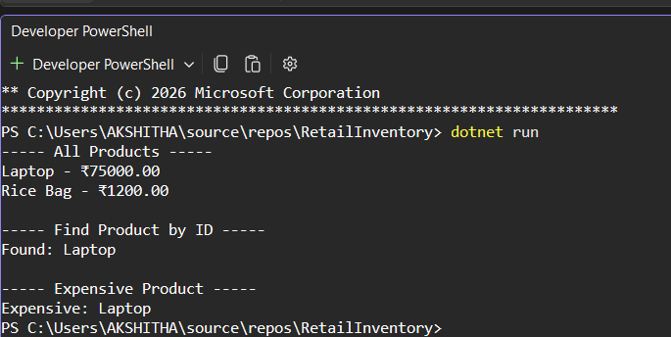

Lab 6: Updating and Deleting Records
Scenario
The retail store needs to update product prices and remove discontinued products from the inventory database.
Objective
To learn how to update and delete records in a SQL Server database using Entity Framework Core.
Opened the Existing Project
- Opened the RetailInventory project in Visual Studio.
- Used the existing SQL Server database (RetailInventoryDB) created in the previous labs.
Opened Program.cs
- Opened the Program.cs file.
- Replaced the previous code with code to update and delete records using Entity Framework Core.

using Microsoft.EntityFrameworkCore;
using RetailInventory.Data;

using var context = new InventoryContext();

try
{
// ----------------------------
// Update Product
// ----------------------------
Console.WriteLine("Updating Product...");

var product = await context.Products
.FirstOrDefaultAsync(p => p.Name == "Laptop");

if (product != null)
{
product.Price = 70000;

await context.SaveChangesAsync();

Console.WriteLine("Laptop price updated successfully.");
}
else
{
Console.WriteLine("Laptop not found.");
}

Console.WriteLine();

// ----------------------------
// Delete Product
// ----------------------------
Console.WriteLine("Deleting Product...");

var toDelete = await context.Products
.FirstOrDefaultAsync(p => p.Name == "Rice Bag");

if (toDelete != null)
{
context.Products.Remove(toDelete);

await context.SaveChangesAsync();

Console.WriteLine("Rice Bag deleted successfully.");
}
else
{
Console.WriteLine("Rice Bag not found.");
}
}
catch (Exception ex)
{
Console.WriteLine(ex.Message);
}

Updated an Existing Product
- Retrieved the Laptop product from the Products table using the FirstOrDefaultAsync() method.
- Checked whether the product existed in the database.
- Updated the product price from ₹75,000 to ₹70,000.
- Saved the updated value to the database using SaveChangesAsync().
Deleted a Product
- Retrieved the Rice Bag product using the FirstOrDefaultAsync() method.
- Checked whether the product existed in the database.
- Removed the product from the Products table using the Remove() method.
- Saved the changes to the database using SaveChangesAsync().
Built the Project
- Built the project successfully in Visual Studio.
- Verified that the project compiled without any errors.
Result:
- Build completed successfully.
Executed the Application
- Ran the application using Ctrl + F5 or the dotnet run command.
- The application connected to the SQL Server database.
- Updated the price of the Laptop product.
- Deleted the Rice Bag product from the database.
Verified the Database
- Opened SQL Server Management Studio (SSMS) or SQL Server Object Explorer.
- Executed the following SQL query:

select * from Products;

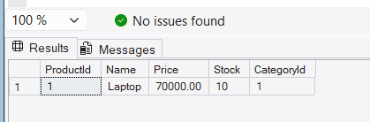
Output:
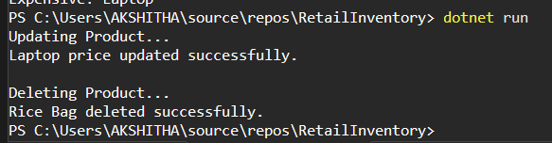

Lab 7: Filtering and Sorting Data Using LINQ
Scenario
The store wants to filter and sort products for reporting.
Objective
Learn how to use:
- Where()
- OrderByDescending()
- Select()
- ToListAsync()
Open the Existing Project
Open Visual Studio.
Open your project:
RetailInventory
Open Program.cs
Replace the Existing Code
using Microsoft.EntityFrameworkCore;
using RetailInventory.Data;

using var context = new InventoryContext();

try
{
Console.WriteLine("----- Filtered and Sorted Products -----");

var filtered = await context.Products
.Where(p => p.Price > 1000)
.OrderByDescending(p => p.Price)
.ToListAsync();

foreach (var product in filtered)
{
Console.WriteLine($"{product.Name} - ₹{product.Price}");
}

Console.WriteLine();

Console.WriteLine("----- Product DTOs -----");

var productDTOs = await context.Products
.Select(p => new
{
p.Name,
p.Price
})
.ToListAsync();

foreach (var item in productDTOs)
{
Console.WriteLine($"{item.Name} - ₹{item.Price}");
}
}
catch (Exception ex)
{
Console.WriteLine(ex.Message);
}
Build the Project
Build succeeded.
Run the Project
Press:
Ctrl + F5
or open the terminal in your project folder and run:
dotnet run

Output:
